**“ROBOPET COMPANION: A Revolutionary Mental Health Support System”**

A Project Report submitted in partial fulfillment of the requirements for the award of the degree of

**MASTER OF TECHNOLOGY**

**IN**

**COMPUTER SCIENCE AND ENGINEERING**

**(Specialization in Data Science)**

Submitted by

**Nallana Chakravarthula. Sai Meghana (2023000914)**

Under the esteemed guidance of

**Dr. T. MOHANA NAGA VAMSI, Ph.D.**



**DEPARTMENT OF COMPUTER SCIENCE AND ENGINEERING**

**GITAM SCHOOL OF TECHNOLOGY**

**GITAM (Deemed to be University)**

**VISAKHAPATNAM**

**March-2025**

**DEPARTMENT OF COMPUTER SCIENCE AND ENGINEERING**

**GITAM SCHOOL OF TECHNOLOGY**

**GITAM (Deemed to be University)**

**DECLARATION**

I hereby declare that the project report entitled “ROBOPET COMPANION: A Revolutionary Mental Health Support System” is an original work done in the Department of Computer Science and Engineering, GITAM School of Technology, GITAM (Deemed to be University) submitted in partial fulfillment of the requirements for the award of the degree of M.Tech. Computer Science and Engineering (DS). The work has not been submitted to any other college or University for the award of any degree or diploma.

Date:

Registration No(s) Name(s) Signature

**DEPARTMENT OF COMPUTER SCIENCE AND ENGINEERING**

**GITAM SCHOOL OF TECHNOLOGY**

**GITAM (Deemed to be University)**

**CERTIFICATE**

This is to certify that the project report entitled “ROBOPET COMPANION: A Revolutionary Mental Health Support System” is a bonafide record of work carried out by Nallana Chakravarthula. Sai Meghana (2023000914) submitted in partial fulfillment of requirement for the award of degree of Master of Technology in Computer Science and Engineering (DS).

Date :

Project Guide Head of the Department

**ACKNOWLEDGEMENT**

I would like to thank **Dr. T. Mohana Naga Vamsi, Ph.D.,** from the bottom of my heart for his relentless support, unstinting encouragement, and rich guidance throughout this project. His enthusiasm to venture beyond horizons has really encouraged me to transcend my boundaries and improve my learning.

I am also greatly indebted to **Dr. Padala Anuradha, Ph.D.,** and **Dr. Ravi Bhramaramba**, **Ph.D.,** whose meticulous scrutiny and critical assessments were instrumental in shaping my work. Their constructive criticisms and astute observations assisted me in finishing the project within the allotted time, maintaining its quality and accuracy.

In addition, I would like to thank our year coordinator, **Dr. Karu Prasada Rao**, **Ph.D.,**for his understanding and support. His patience and guidance in steering me through problems have been reassuring beyond words, enabling me to remain focused and dedicated to my aspirations.

I am very thankful to each one of them for their time, effort, and motivation, which have proved vital in completing this project to a successful outcome. Their assistance not only benefited me academically but has also motivated me to perform the best in every undertaking.

N.CH. Sai Meghana (2023000914)

**TABLE OF CONTENTS**

|  |  |  |
| --- | --- | --- |
| **S.No** | **Description** | **Page Number** |
| **1** | **Abstract** | **1** |
| **2** | **Introduction** | **2** |
| **3** | **Literature Review** | **3 to 5** |
| **4** | **Problem Identification & Objective** | **5 to 9** |
| **5** | **Existing System** | **9 to 12** |
| **6** | **Proposed System** | **12 to 18** |
| **7** | **System Architecture /Methodology** | **18 to 24** |
| **8** | **Technology/Tools Used** | **25** |
| **9** | **Implementation** | **25 to 27** |
| **10** | **Result & Discussion** | **27 to 36** |
| **11** | **Future Scope & Conclusion** | **36 to 37** |
| **12** | **Reference** | **38 to 39** |

1. **ABSTRACT**

Mental health issues, including depression, anxiety, low self-esteem, and stress, are common across different age groups and genders. Nonetheless, it is essential to be aware of mental health resources and to be to seeking assistance in order to tackle these problems effectively. This project presents the results of a survey analyzing mental health conditions and barriers in accessing mental health support. We utilized Power BI’s DAX formulas to highlight important indicators such as persistent stress, thoughts of self-harm, difficulties in decision-making, and inadequate access to mental health resources. The results indicate that, although many people are open to seeking help, there is a notable lack of awareness and access to the necessary mental health resources. From the study comes the birth of MAA(Mental health Assistance Ally); it is known as the Mobile Application designed with mental health in mind, thus assisting individuals seeking mental health services. Some key features are presented, such as personality testing like GAD,BDI,PSS(GAD-7: Generalized Anxiety Disorder Test, BDI: Beck Depression Inventory, PSS: Perceived Stress Scale), panic attack aids, mood track, nonjudgmental bot for chat purposes, journal writing by capturing true emotion i.e., even though person not in a good state but still mask it like they are so, while journaling we capture the text sentiment analysis and face real emotion detection, to-do lists, ideas for meditation and motivation, among others, privacy enhanced. The paper discusses the conceptualization of a robotic pet that serves as an AI-driven emotional companion, thus attempting to try to give continuous mental health assistance.

1. **INTRODUCTION**

Mental well-being is crucial for general health, affecting emotional, psychological, and social life. Conditions such as anxiety and suicidal ideation are on the rise globally [1], but most people do not access help because they lack awareness, fear judgment, or stigma. This paper discusses people’s readiness to access mental health care and the challenges they encounter, including limited resource availability. Through the examination of survey data by age groups through DAX-based analysis, the research reveals issues such as stress, decisionmaking challenges, and judgment concerns and provides recommendations for improving mental health support. Contrary to the conventional goal-oriented behavioral methods, this research focuses on user needs understanding to create effective mental health support. With this aim, the Mental Health Assistance Ally (MAA) mobile app was developed, featuring guided meditation, panic attack assistance, mood monitoring, sentiment-analyzing journaling, and facial emotion recognition to gauge users’ mental conditions and avoid negative thoughts. The follow-up development is the humanoid desktop robo-pet, an AI-powered companion with MAA integration to maximize real-time emotional monitoring and automation. Armed with AI-based sentiment analysis, advanced data security, and interactive interaction, the robo-pet provides personalized care through the analysis of behavior patterns, decision-making support, and positive mindset enhancement. Through bridging AI companionship with emotional well-being, this technology revolutionizes mental health care through an interactive, responsive, and secure personal assistant.

1. **LITERATURE REVIEW**

## In recent years, the field of human–robot companionship (HRC) has gained significant attention, particularly in mental health applications. Research has shown that humans tend to form strong emotional bonds with zoomorphic or Anthropomorphic robots due to their animal-like, Human- like appearance and behavior, which mirrors the natural attachment people have with pets [3]. This attachment is particularly effective in providing emotional support and alleviating feelings of loneliness, especially in vulnerable populations such as the elderly or individuals with mental health challenges. Building on these findings, we propose ”Robopet,” a zoomorphic or Anthropomorphic robotic companion designed to simulate the benefits of human-animal interaction. Robopet will act as a supportive companion by offering emotional engagement and monitoring users’ mental health indicators, making it a promising solution for improving emotional well-being through technology. This approach is informed by the growing body of literature that emphasizes the effectiveness of animal like or human-like robots in fostering emotional connections and promoting mental health [3].

## A large scale quantitative study was performed to examine the impact of a humanoid robot on affect and interpersonal relationships of elders. The authors have used a survey question to evaluate how the Nao robot[4] could stimulate seniors’ social communication and prevent loneliness. With regard to the study, it was agreed that the response from the robot not only was an effective social and emotional support platform but also promoted actual communication, and accordingly, it appeared that the robot could be used for improving social inclusion and preventing social isolation among the elderly users. In another quantitative investigation, the researchers analyzed the effects of the CuDDler, an animal-liked robot, on the mood stimulating and stimulating activity of the elderly[2]. While some participants showed positive attitude toward the robot, some were negative probably because the robot was large and looked toy like than their expectation of their age group. In this study emphasis was made on how social aspects such as perceived emotional and cultural response of the target end-users can influence their acceptance of assistive robots, consequently this means that the design characteristics of such robots must be given serious considerations. Another coherent study ascertained the impact of a companionship robot on the students’ well-being, mood, and desire for behavioral variability for better well-being of MIT students[5]. Thus, 62.86% of them indicated that a robot offered them companionship and they would like to talk with the robot[6]. Still, 32.29% of the participants expressed uncomfortable with proactive characteristics of the robot; they are worried about privacy since the robot is equipped with a camera and microphones. This brings out the aspect of integration of functional, practical and sometimes privacy aspects when developing and constructing social robots.

## A subsequent was carried out to explore the view of the socially assistive robot “Stevie” from the residents and the staff of a LTC. Early responses came in response to how users first come into contact with the robot, specifically when a visitor would say that it was ‘cute,’[7] leading to increased curiosity and consequent engagement among the users. Yet participants also offered more than twenty use cases of possible enhancements listing specific ways the system may serve the needs of users improved. This speaks to the importance of Iterative design and feedback in developing improvements to assistive technologies.

## One experiment, based in Germany, found how leaving a ‘robot companion’ with senior citizens[8], without the presence of a human carer, for a week. In the first phase, 60% of the respondents gave positive comments about the design quality; however, they identified such drawbacks as problems with orientation in a specific area. After responding to these concerns, the second phase of a survey had a higher approval rating of 90 per cent among the participants. Consequently, this study emphasizes that more acceptance of robotic technologies has to begin with constant improvements and sleekness to the needs of its users. Likewise, the evaluation done on the GoldenPup, an animal like robot, showed that it helped to establish a close relationship with elderly users[9]. Some of the participants claimed they felt emotionally bonded to the robot and found familiar warm robotic appearance easy to accept and interact with and that signified that pet-like appearance inspires a sense of comfort and easy acceptance among older adults.

## Ryan[10], MARCo[11], Samsung BotCare[12], Eilik[13], LOVOT[14], MIKO3[15], MISA[16] doesn't have decision assistance feature in it.

## Based on these studies my research paper has formed a novel strategy by carrying a survey prior to the creation and development of a humanoid robot for psychiatric counseling. Unlike forming a robot first and looking for an target audience, in this work, the goal is to get as much information on which characteristics and features of such a robot are desired by the pre-selected age groups. As a result of the need to ascertain prior to development what specific needs and expectations consumers may have of the final product, this research aims at guaranteeing that the developed robot will both meet an intended function and be well received by its probable user base. This will result in the creation of a robot that is practical and assist objective regarding issues of mental health counselling but will also lean towards the cultural and emotional standards of the users making it more fit for real world integration.

1. **PROBLEM IDENTIFICATION AND OBJECTIVE**

Mental health is a critical issue globally, with increasing rates of stress, anxiety, depression, and suicidal thoughts affecting individuals across various age groups and demographics. Despite the availability of mental health services, many people do not seek assistance due to barriers such as limited access, stigma, lack of awareness, and privacy concerns. This pressing issue has been highlighted by reports from global health organizations, such as the World Health Organization (WHO) [1], which emphasize the urgent need for a transformation in mental health care systems worldwide.

To better understand the scope of this problem, we conducted a survey involving 255 participants from diverse age groups. The survey revealed significant gaps in both awareness of mental health resources and accessibility to support systems. Over 70% of the respondents expressed a willingness to seek help for their mental health issues, including stress, low self-esteem, and emotional distress. However, they were often hindered by a lack of resources, fear of judgment, and concerns about privacy.

The survey results confirmed the need for a continuous, accessible, and stigma-free solution that addresses these gaps. The data collected from the survey is summarized in **Table 1& Fig 1**. The table highlights various mental health Fig. 1 indicators such as Decision Doubt, Depression, Stress, Internal Pain, Fear of Judgment, Low Confidence, Self-Harm, and the tendency to Seek Help across different age groups and genders.

#### Table 1: Survey data according to the age and issue

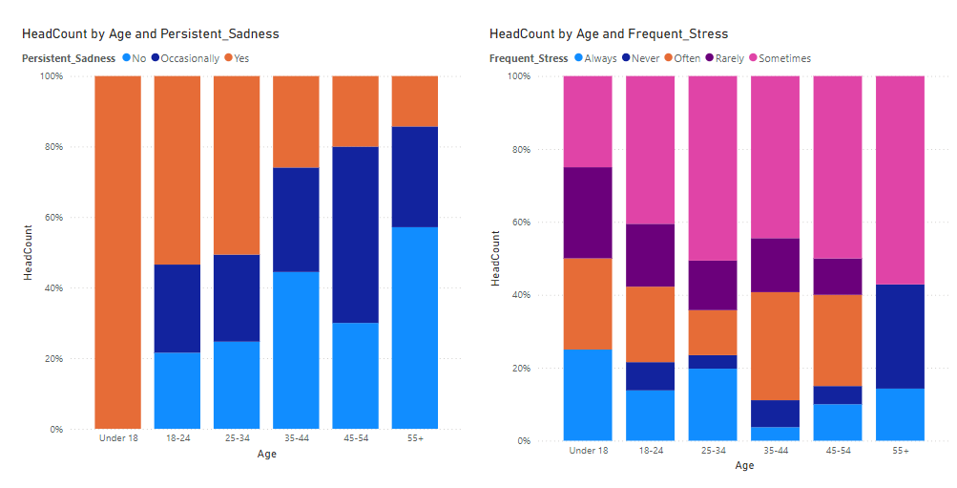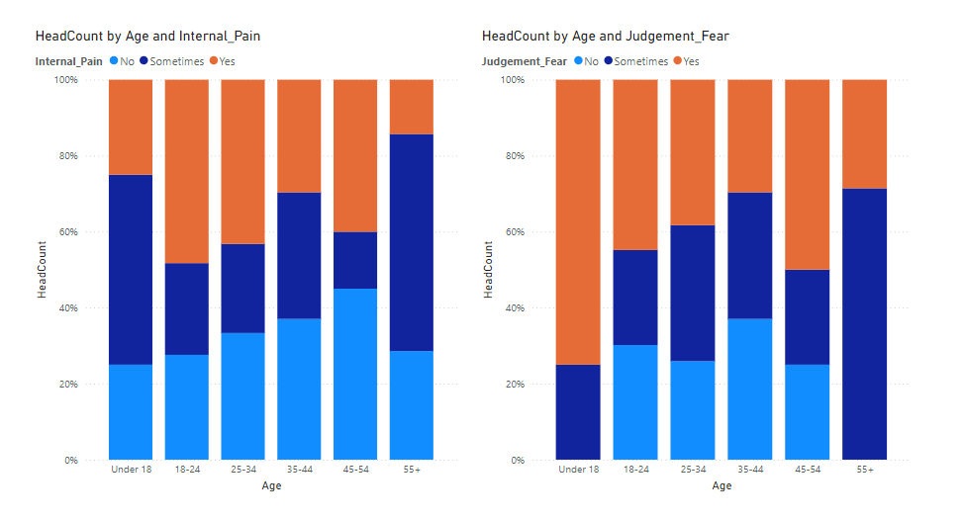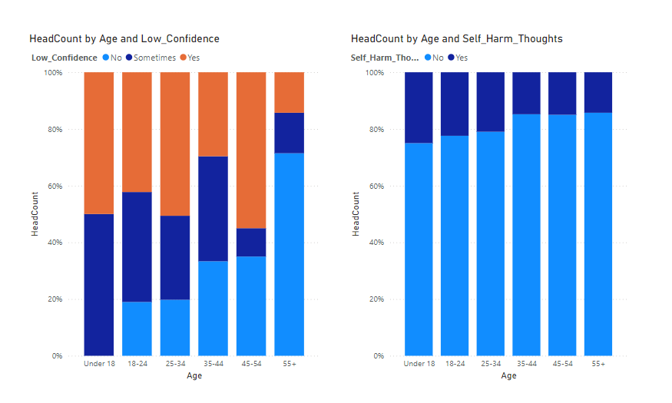

**Figure 1: Age Distribution and Mental Health Indicators by Age Group**

.

The findings highlight the critical role that innovations like RoboPet can play in bridging this divide by leveraging advanced robotics, artificial intelligence, and data privacy measures. It acts as a friendly mental health counsellor, offering 24/7 support through personalized interactions. Using image and voice recognition technology, it can detect emotions and respond accordingly, providing companionship, mood regulation, and decision-making assistance. Its portable design ensures that individuals have access to support wherever they go Within a specific area, overcoming the limitations of traditional counselling services.

**Survey Analysis and Insights:** Conduct a comprehensive survey to assess mental health conditions across various demographics, identifying key factors such as persistent stress, decision-making difficulties, and limited access to resources.

**Data Analysis Using Power BI and DAX:** Utilize Power BI's DAX formulas to derive meaningful insights from survey data, highlighting significant mental health indicators such as self-harm thoughts and resource availability gaps.

**Development of the MAA Application:** Design and develop the Mental Health Assistance Ally (MAA) mobile application to assist individuals in accessing mental health services. Incorporate personality tests (GAD-7[18], BDI, and PSS[19]), panic attack aids, mood tracking, journaling with sentiment analysis, and motivational resources.

**Sentiment Analysis and Emotion Detection:** Implement facial emotion detection and text sentiment analysis during journaling to capture users' true emotional states, even when masked by optimistic language.

**Robotic Pet Companion Concept:** Conceptualize a humanoid robotic pet as an AI-driven emotional companion to provide continuous mental health assistance and companionship. Enhance real-time emotional tracking and interactive engagement.

**Confidentiality and Security:** Ensure privacy and data security through encryption and secure access controls within the MAA application and robotic companion features.

**Addressing Barriers to Mental Health Assistance:** Explore the willingness of individuals to seek mental health support and identify challenges, including stigma and resource limitations, to enhance support mechanisms.

**Targeted Mental Health Monitoring:** Establish criteria for classifying mental health conditions (e.g., anxiety, depression, and stress levels) and generate automated alerts to guardians in critical cases.

**User-Centered Design and Iterative Improvement:** Gather user feedback to iteratively refine the design of the robotic pet and ensure its adaptability to different user requirements.

**Future Research:** Expand research on the impact of the humanoid robot on diverse social groups and improve its functionalities to become socially intelligent and seamlessly integrated into daily life.

1. **EXISTING SYSTEM**

Most available interventions for mental health support are based on traditional counselling services. However, traditional approaches to behavioral health have limited accessibilities, while counselling may result in stigma and concerns of information privacy. Thus, although a few digital mental health applications are present, they rarely allow real-time intervention without information privacy. As such, the Robopet Companion tool compensates for the limitations of traditional counselling services because the usage of tool-based approaches and advanced robotics ensures continuous personalized support and feedback due to superior artificial intelligence.

Other existing solutions to the identified problem of inadequate mental health support include typical approaches, such as visiting a therapist, joining a support group, or taking medication, as well as relatively new interventions, such as digital mental health applications and teletherapy. Nevertheless, all of them have their downsides.

**1.TRADITIONAL THERAPY SESSION:**

Although therapy sessions offered by mental health professionals are useful, they are also accompanied by various restrictions. Appointments may be hard to schedule and people may have to wait several months to be seen. Moreover, therapy sessions are limited in time and cannot be provided when an individual is in distress or experiencing a crisis.

**2.SUPPORT GROUPS:**

Support groups offer individuals the opportunity to connect with others facing similar challenges. However, participation in support groups may be limited by factors such as geographical location, scheduling conflicts, or social anxiety. Additionally, support groups may not provide the personalized support and guidance needed by individuals struggling with complex mental health issues.

**3.MEDICATION:**

Depression and anxiety are often kept in check with medication. This solution may work for some, but it does not treat the cause and side effects can become a problem. At that, medication does not substitute comprehensive mental support even if mental issues are treated effectively in the short-term.

**4.DIGITAL MENTAL HEALTH APPLICATIONS:**

Digital mental health applications have gained popularity as an easy-to-reach a

comfortable replacement for traditional interventions. These applications commonly include mood tracking, guided meditation, psychoeducation, and others. Yet, the majority of digital

mental health applications fail to function as real-time interventions that could help people in crisis be safe. Additionally, the offered support that could potentially minimize poor mental health and develop better coping mechanisms is not individualized and fails to meet the majority of the people’s preferences. Lastly, because of the high rate of stolen data and the lack of guarantees for privacy, individuals are also reluctant to use these applications.

**5.TELETHERAPY SERVICES:**

Teletherapy services refer to therapy sessions provided remotely through video conferencing or phone calls. Teletherapy can be beneficial in making these services more accessible to people with mobility impairments and in remote areas. However, teletherapy may not be suitable for all clients, as technical difficulties, poor internet access, or privacy and confidentiality concerns may be limitations to using such services.

In conclusion, currently known solutions to the problem of insufficient mental health support have a few barriers to access, inflexibility and insufficient personalization, as well as privacy and confidentiality issues. These disadvantages suggest the necessity of creating new, innovative interventions such as the Robopet Companion which could address the restrictions identified above by offering non-stop, personalized, and self-sufficing support for anyone in need.

Drawbacks of these known solutions include:

The drawbacks of known solutions to the problem of inadequate mental health support include:

**1.BARRIERS TO ACCESS:**

Traditional methods such as therapy sessions often come with barriers to access, including long waiting periods for appointments and limited availability during times of crisis. This can result in delays in receiving support, particularly for individuals in acute distress or contemplating self-harm.

**2.STIGMA AND PRIVACY CONCERNS:**

There is a pervasive stigma surrounding mental health issues, which can deter individuals from seeking help. Concerns about privacy and confidentiality may also prevent individuals from openly discussing their struggles or accessing support service

**3. LACK OF FELXIBILITY**

Traditional therapy sessions are typically scheduled for fixed durations and may not be available during times of acute need. This lack of flexibility can leave individuals feeling unsupported and isolated during moments of crisis.

**4. LIMITED PERSONALIZATION**

Support groups and digital mental health applications may lack the personalized support and guidance needed by individuals struggling with complex mental health issues. One-size-fits- all approaches may not adequately address the diverse needs and experiences of individuals.

**5.SIDE EFFECTS OF MEDICATION**

While medication can be effective for managing symptoms of mental health conditions, it may also come with side effects. Additionally, medication alone may not address the underlying causes of mental health issues or provide the comprehensive support needed for long-term well-being

**6.TECHNICAL DIFFICULTIES AND INTERNET ACCESS**

Teletherapy services rely on internet connectivity and technology, which may pose challenges for individuals with limited access to reliable internet or technical difficulties with devices. This can create barriers to accessing remote mental health support services.

**7.GEOGRAPHICAL LIMITATIONS:**

Support groups and traditional therapy sessions may be limited by geographical location, making it difficult for individuals in remote areas to access mental health support services. This can result in disparities in access to care based on location.

**8. LIMITED AVAILABILITY FOR CHILDERN:**

Existing solutions may not be tailored to the needs of children and adolescents, who may require specialized support and guidance in navigating their mental health challenges. This can result in gaps in mental health care for younger populations.

Overall, the drawbacks of known solutions highlight the need for innovative interventions like the Robopet Companion, which aims to overcome these challenges by providing continuous, personalized, and accessible support to individuals of all ages and backgrounds.

1. **PROPOSED SYSTEM**

**1.DATA COLLECTION FOR SURVEY:**

The survey gathered responses from 255 participants, including students, employed individuals, and others. Closed ended questions were used to assess the state of mental health and the availability of support.

• Gender, Age, Occupation

• Frequency of stress or anxiety in the past month

• Impact of low confidence on daily life

• Persistent feelings of sadness, hopelessness, or depression

• Thoughts of self-harm or suicide

• Difficulty making decisions due to self-doubt or fear of judgment

• Coping mechanisms for stress or emotional pain

• Access to mental health resources (e.g., counseling, support groups)

**2.SURVEY DESIGN AND DISTRIBUTION**:

The survey comprises 15 questions aimed at identifying respondent’s mental health condition, his or her access to resources for mental health, and readiness to receive help. The investigated frequency factors are stress often, low selfconfidence, chronic depression, decision-making complexities and judgement phobia. The survey was conducted with equal portion questions related to age, gender and age wise splitting of responses was also done.

Power BI and DAX expressions were used for analyzing the data. Every mental health factor was derived by applying query on its DAX as presented in the DAX calculation to identify the number of affected individuals, with specific mental health issues. Demographic characteristics, resource accessibility, and willingness to seek help and the absence of the required resources were on the foreground of the analysis.

Key calculations:

• Frequent Stress: Number of respondents who said they experienced stress “Often” or “Always.”

• Low Confidence Impacting Life: Number of people who gave a “Yes” or ”Sometimes” response to questions related to confidence.

• Depression: Number of cases of people having episodes of sadness, hopelessness or depression.

• Self-Harm Thoughts: Number of people who had ideas of self- harm or harming themselves.

• Decision-Making Issues: Number of people experiencing decisional conflicts attributable to uncertainty or avoidance of erroneous decisions.

• Lack of Access to Mental Health Resources: Number of people with no externally provided mental health resource.

**3.MOBILE APP MAIN FEATURES:**

**(1)Personality Test**

GAD-7: Generalized Anxiety Disorder Test : Score Rating: 0 = Not at all, 1 = Several days, 2 = More than half the days, 3 = Nearly every day

• Feeling nervous, anxious, or on edge

• Not being able to stop or control worrying

• Worrying too much about different things

• Trouble relaxing

• Being so restless that it is hard to sit still

• Becoming easily annoyed or irritable

• Feeling afraid as if something awful might happen

BDI: Beck Depression Inventory: Score Rating :0 = Not at all, 1 = Mildly, 2 = Moderately, 3 = Severely

• Sadness

• Pessimism

• Past Failure

• Loss of Pleasure

• Guilty Feelings

• Punishment Feelings

• Self-Dislike

• Self-Criticalness

• Suicidal Thoughts or Wishes

• Crying

• Agitation

• Loss of Interest

• Indecisiveness

• Worthlessness

• Loss of Energy

• Changes in Sleeping Pattern

• Irritability

• Changes in Appetite

• Concentration Difficulty

• Tiredness or Fatigue

• Loss of Interest in Sex

PSS: Perceived Stress Scale: Score Rating : 0 = Never, 1 = Almost never, 2 = Sometimes, 3 = Fairly often, 4 = Very often

• In the last month, how often have you been upset because of something that happened unexpectedly?

• In the last month, how often have you felt that you were unable to control the important things in your life?

• In the last month, how often have you felt nervous and stressed?

• In the last month, how often have you felt confident about your ability to handle your personal problems?

• In the last month, how often have you felt that things were going your way?

• In the last month, how often have you found that you could not cope with all the things that you had to do?

• In the last month, how often have you been able to control irritations in your life?

• In the last month, how often have you felt that you were on top of things?

• In the last month, how often have you been angered because of things that were outside of your control?

• In the last month, how often have you felt difficulties were piling up so high that you could not overcome them?

If GAD score is less than or equal to 4 consider it as ”Minimal Anxiety” , if GAD score in between are equal to 5 9 then it is a ”Mild Anxiety”, if GAD score is in between or equal to 10 14 then ”Moderate Anxiety” else ”Severe Anxiety.”

If BDI score is less than or equal to 13 consider it as ”Minimal Depression” , if BDI score in between are equal to 14 19 then it is a ”Mild Depression”, if BDI score is in between or equal to 20 28 then ”Moderate Depression” else ”Severe Depression.”

If PSS score is less than or equal to 13 consider it as ”Low Stress” , if PSS score in between are equal to 14, 26 then it is a ”Moderate Stress” else ”High Stress.” If GAD Score greater than or equal to 10 or BDI Score greater than or equal to 20 or PSS Score greater than or equal to 27 we will send mail to the guardian of the patient that Based on these scores, we would like to bring to your attention that your child may be experiencing a level of anxiety, depression, or stress that warrants attention. We encourage you to have a conversation with your child and consider seeking support or professional counseling if necessary. Please reach out to us if you would like further discussion or assistance in supporting your child’s well-being

**(2)Personality Test**

Writing in the journal is basically describing how your day has been. Yet, sometimes the text does not reveal one’s current feelings. A person experiencing difficulties can write something optimistic. Our system captures continuously facial expressions with the help of DeepFace and analyses text emotions using the IMDb dataset while the user is writing in the journal, thereby achieving a much more accurate emotional understanding until the end of the journaling session

**(3)Chatbot**

A customized chatbot was developed for mental health counseling that is integrated with a specialized dataset. In the event that a user’s query does not match any data within the dataset, the chatbot will seamlessly call the Gemini API to retrieve a relevant response. Also, the system includes a security feature concerning safety and welfare of the user; as if the user mentions sensitive or offensive terms related to self-harm or suicides, automated alert emails are sent to the nominated guardian asking them to reach out to the user for timely support.

**(4)Mobile App Other Features**

The application offers a holistic approach to mental wellbeing, especially in managing panic attacks. If a user experiences a panic attack, they can click the ”Calm” button to access guided breathing exercises. If these exercises are ineffective, an SOS emergency button is available to immediately contact their guardian, notifying them of the attack’s duration and triggering factors.

Meditation is another main feature, providing users with insights into practices from Art of Living and the benefits of breathing techniques like Sudarshan Kriya[17]. Moreover, the app introduces foundational knowledge of yoga to support mental and physical balance.

This has been encouraged with the ”One-Day, One-Streak” concept, wherein a streak of 30 days consecutively leads to planting a plant in the user’s name as a reward. Other features include mood tracking and to-do lists that increase productivity and encourage personal development.

**4.APPLICATION INTERFACE:**

The Robopet Companion is accompanied by a user-friendly mobile application, which serves as a central hub for managing interactions and accessing support services. Through the application, users can customize their preferences, set reminders for self-care activities, and track their mood and progress over time. The application also facilitates communication between the Robopet Companion and authorized caregivers or mental health professionals, allowing for seamless coordination of care.

**5. INTERACTION AND MOBILITY:**

The Robopet Companion interacts with users through a combination of voice commands, gestures, and tactile feedback. It is capable of moving autonomously within its environment, using sensors and cameras to navigate and respond to user movements. The device can detect when the user is in distress or in need of support, proactively initiating interactions to provide comfort and assistance.

1. **PROPOSED SYSTEM ARCHITECTURE / METHODOLY**

The overall theme and concept of this project are visually represented in Figure 2 below, providing a clear illustration of the system's structure and flow. This diagram serves as a high-level overview, encapsulating the core elements and interactions that define the project's functionality. 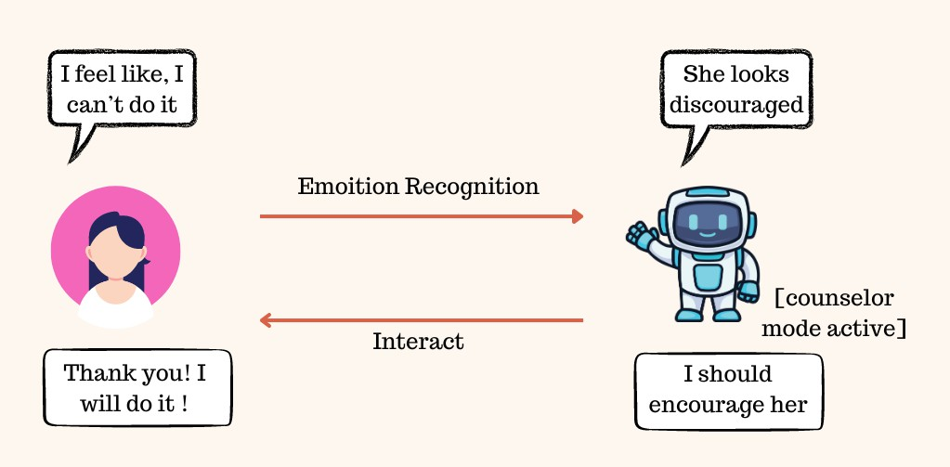

**Figure 2: Theme of the work**

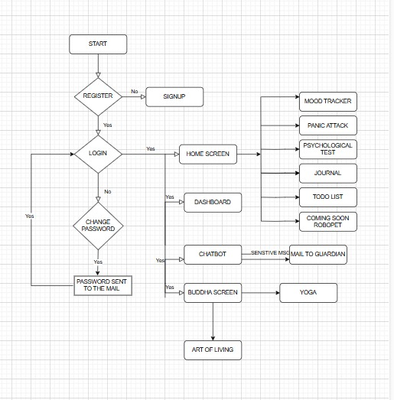

**Figure 3: Workflow of Mobile Application**

**Mobile Application:**

The following is the workflow and functionality of the Mental Health Assistance Ally (MAA) app when installed.

**1. Splash Screen**

The app starts with five splash screens: Figure 4, Clearhead, Relax, Exercise, Mood Daily, and Welcome. All of them have an image and a motivational quote to increase user interaction and give an idea about the purpose of the app. The Welcome screen has Login and Sign-Up buttons for user login.

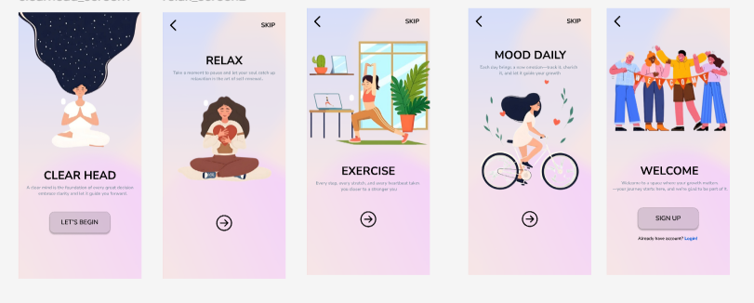

**Figure 4: Splash Screens**

**2. Login Screen**

Figure 5, Existing customers can log in with their registered email ID and password. The system checks for the credentials, and if they are wrong, it asks for the correct credentials.

**3. Change Password**

In case the user has forgotten the password, Figure 5, he/she can request a password change, after which an email containing the existing password is sent. Users can then log in with these credentials.

**4. Sign-Up Screen**

New users are required to register to access the app. Figure 5,The registration process involves the following information:

User Information: Name, Email, Password, and Phone Number.

Guardian Information: Name, Relation, Email, and Phone Number (for safety and well-being of the user).

Terms and Conditions: Users are required to agree to the app's terms prior to proceeding.

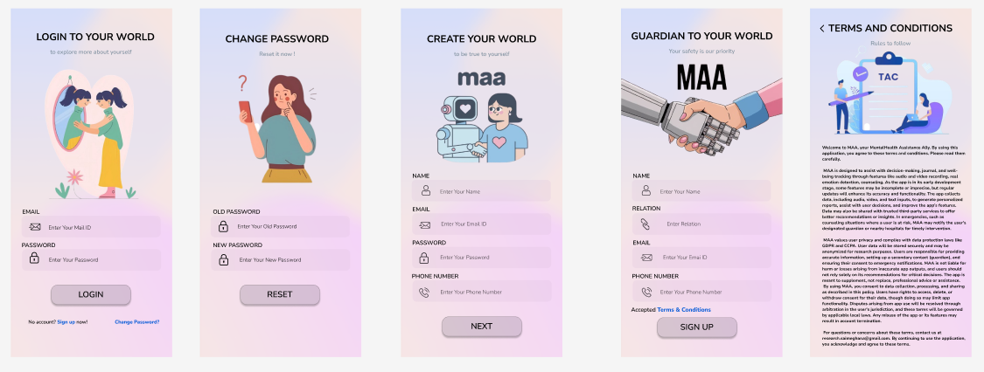

**Figure 5: Login, Signup and T&C Screen**

**5. Home Screen**

After logging in, Figure 6 users are taken to the Home Screen, which offers access to main features:

Mood: Enables users to monitor their daily moods.

Test: Performs personality tests for stress, anxiety, and depression.

Calm: Gives relaxation exercises.

Journal: Acts as an electronic diary for personal journaling.

Productivity: Provides a to-do list capability where users can create CRUD (Create, Read, Update, Delete) operations. Tasks of past dates are read-only for referencing.

Coming Soon – RoboPet: A future feature in the plan.

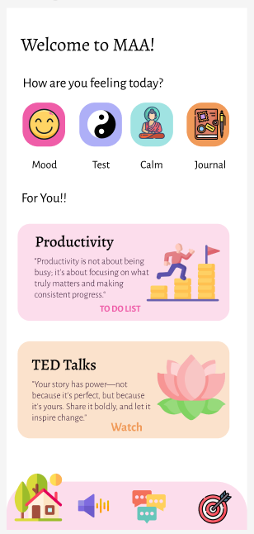

**Figure 6: Home Screen**

**6. Natural Way Screen**

This feature encourages Figure 7, mindfulness and self-well-being through two key features:

Yoga: Provides theoretical and practical yoga instructions, such as voiceover guidance and progressive levels.

Art of Living[20]: Sends users to the official Art of Living website for expert sessions.

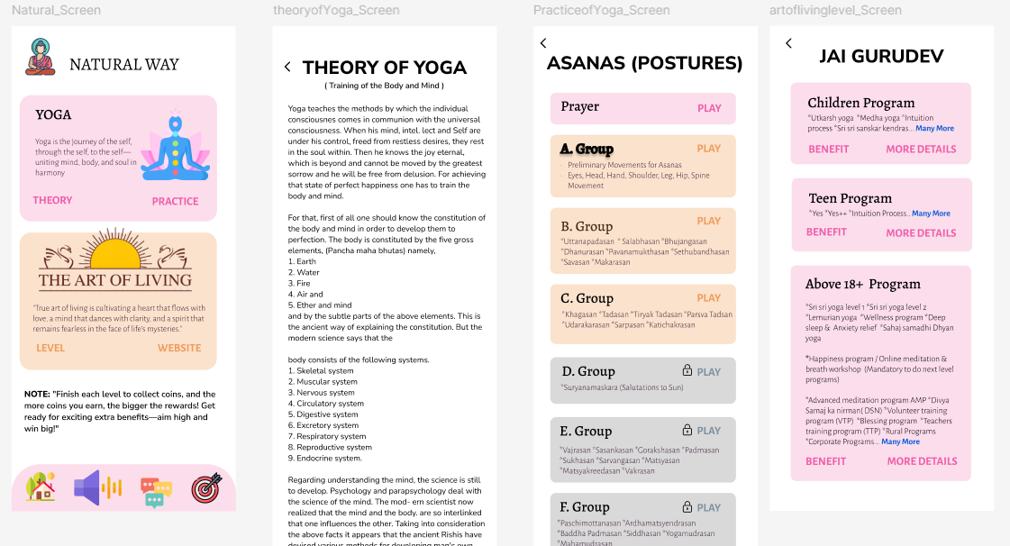

**Figure 7: Natural way Screen**

**7. Chatbot Screen**

Serves as a virtual guide by having chatty conversations with users. It relies on an intent-based dataset (intent.json) for the responses. Where the chatbot is unable to respond, assistance comes from the Gemini API. In the event of sensitive keywords, an alert email is dispatched to the guardian for user security.

**8. Dashboard Screen**

Shows motivational quotes and streaks to motivate continuous use of the app.

|  |  |  |  |  |  |
| --- | --- | --- | --- | --- | --- |
| FNo | Feature | Model/Method | Dataset/ Data required | Status | Mobile Integration |
| 1 | Journalling (Text + Face Emotion Detection) | LSTM + DeepFace | IMDB + Real time camera | Done | Pending |
| 2 | Journal – Email (If user text contains sensitive harmful data die, kill, suicide etc) | smtp | Guradian mail id | Done | Done |
| 3 | Personality Test (BDI – Depresion test, PSS – Stress, GAD - Anxiety) | Conditional | User input analysis | Done | Done |
| 4 | Personality Test – Email (Moderate & High level) | smtp | Guardian Mail id | Done | Done |

1. **TECHNOLOGY USED**

|  |  |
| --- | --- |
| **Purpose** | **Used** |
| IDE | Visual studio code, Jupyter notebook, mobile emulator |
| Programming language | Python, Dart |
| frontend | Flutter |
| UI/UX design | Figma |
| Database | Firebase |

1. **IMPLEMENTATION**

BEGIN

FUNCTION train_text_emotion_model():

LOAD dataset (IMDB) with specified word limit

PREPROCESS text data by padding sequences

INITIALIZE Sequential model

ADD Embedding layer

ADD LSTM layer with dropout

ADD another LSTM layer with dropout

ADD Dense output layer with sigmoid activation

COMPILE model with binary cross-entropy loss

TRAIN model on training data with validation split

EVALUATE model accuracy on test data

RETURN trained model

FUNCTION capture_facial_expression(facial_emotions):

INITIALIZE webcam

DISPLAY message: "Capturing facial emotion..."

WHILE camera is active:

CAPTURE frame

IF frame not captured, BREAK loop

ANALYZE frame using DeepFace (emotion detection)

EXTRACT dominant emotion

DISPLAY detected emotion on frame

STORE detected emotion in facial_emotions list

IF user presses 'q', BREAK loop

RELEASE camera and CLOSE window

FUNCTION text_emotion_inference(model, text_input, text_emotions):

INITIALIZE tokenizer with predefined word limit

TOKENIZE user input

CONVERT input into padded sequence

PREDICT sentiment score using trained model

IF prediction > threshold:

ADD 'happy' to text_emotions

ELSE:

ADD 'sad' to text_emotions

FUNCTION run_emotion_analysis():

INITIALIZE lists for facial_emotions and text_emotions

TRAIN text emotion model

START facial emotion detection in a separate thread

GET user text input

START text emotion detection in another thread

WAIT for both threads to complete

PRINT detected text and facial emotions

COMBINE all emotions into a sequence

MAP emotions to numeric values

PLOT emotion trends over time

CALCULATE emotion distribution percentages

DISPLAY emotion percentages

CALL run_emotion_analysis()

END

**10. RESULT & DISCUSSION**

The data collected from the survey is summarized in Table I. The table highlights various mental health Fig. 1 indicators such as Decision Doubt, Depression, Stress, Internal Pain, Fear of Judgment, Low Confidence, Self-Harm, and the tendency to Seek Help across different age groups and genders.

1. Age and Gender Distribution

The survey data was collected from six different age groups: Under 18, 18-24, 25-34, 35-44, 45-54, and 55+. Each of these age groups is further categorized by gender, with responses from Males, Females, and a respondent identifying as 3rd Gender in the 55+ group.

1. Mental Health Indicators

The following mental health indicators were assessed in the survey:

• Decision Doubt: Difficulty in making decisions.

• Depression: The presence of depressive symptoms.

• Stress: Reported levels of stress.

• Internal Pain: Psychological or emotional pain experienced.

• Fear of Judgment: Fear of how others perceive them.

• Low Confidence: Lack of self-confidence.

• Self-Harm: Tendencies toward self-harming behaviors.

• Seek Help: The act of seeking professional help or support.

1. Tool to analysis the data

Power BI was selected over Excel for creating graph as its ability to handle large and complex datasets, advanced visu alization features, powerful and easy DAX calculations, ease of data refresh and integration, enhanced collaboration, and interactive filtering capabilities. These features made Power BI the superior choice for analyzing mental health survey data and extracting meaningful insights, allowing for a more sophisticated and scalable analysis compared to Excel.

1. Analysis of Age Distribution and Mental Health Indicators

The visual representation of age distribution and mental health indicators is shown in Fig. 1. This makes it easy to represent trends with other age groups and makes it easier to show how some conditions like, anxiety or depression take different forms in different age categories. By plotting age against mental health outcomes the figure provides information about which population is more vulnerable to experience ill mental health, and therefore can indicate target population for health promotion and prevention programs. Due to the method used in this structure, it is possible to recognize clearer tendencies and differences in mental health according to age.

1. Observations by Age Group

**Under 18 (4 respondents):**

• Out of 4 the respondents, 75% expressed decision-related type of doubts; 100% said they had low confidence, judgmental fear, and depression; 50% have stress; and 75% had internal pain. Also, 25% of the participants said that they self-harm while 50% were current utilizers of help. Nevertheless, only 30% of people were aware of existing mental health services.

• It is, however, useful to make three observations about the focus group: first, respondents under the age of 18 reported suffering primarily from mental health problems that made them feel insecure, anxious, and fearful of stigma, even violence and self-harm.

**18-24 (116 respondents):**

• Mental Health Challenges (Age 18-24): Among this age group, 62.07% experience decision-related doubts, 78.45% suffer from depression, 34.48% report stress, 72.43% endure internal pain, 69.83% face judgmental fear, and 81.03% struggle with low confidence. Addition ally, 22.41% engage in self-harm.

• Help-Seeking and Awareness: While 73.27% are actively seeking help, 71.33% remain unaware of available mental health resources.

**25-34 (81 respondents):**

• Mental Health Challenges (Age 25-34): Among this age group, 60.49% experience decision-related doubts, 75.31% suffer from depression, 29.75% report stress, 66.67% endure internal pain, 74.07% face judgmental fear, and 80.25% struggle with low confidence. Addition ally, 20.99% engage in self-harm.

• Help-Seeking and Awareness While 74.07% are actively seeking help, 67.65% remain unaware of available mental health resources.

**35-44 (27 respondents):**

• Mental Health Challenges (Age 35-44): Among this age group, 33.33% experience decision-related doubts, 55.56% suffer from depression, 33.43% report stress, 62.96% endure internal pain, 62.96% face judgmental fear, and 66.67% struggle with low confidence. Addition ally, 14.81% engage in self-harm.

• Help-Seeking and Awareness: While 70.37% are actively seeking help, 68.57% remain unaware of available mental health resources.

**45-54 (20 respondents):**

• Mental Health Challenges (Age 45-54): Among this age group, 40% experience decision-related doubts, 70% suffer from depression, 35% report stress, 55% endure internal pain, 75% face judgmental fear, and 65% struggle with low confidence. Additionally, 15% engage in self harm.

• Help-Seeking and Awareness: While 60% are actively seeking help, 71.43% remain unaware of available mental health resources.

**55+ (7 respondents):**

• Mental Health Challenges (Age 55+): Among this age group, 14.29% experience decision-related doubts, 42.86% suffer from depression, 14.29% report stress, 71.43% endure internal pain, 100% face judgmental fear, and 28.58% struggle with low confidence. Additionally, 14.29% engage in self-harm.

• Help-Seeking and Awareness: While 57.15% are actively seeking help, 70% remain unaware of available mental health resources.

1. MAA- Mental health Assistance Ally

***Personality Test*** The mental status examination of the patient has brought the following results: Level of anxiety: Mild Anxiety (Score: 6) Depression Level: Severe Depression (Score: 29) Stress Level: High Stress Score: 40 Figure 8

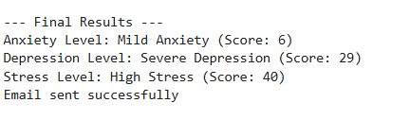

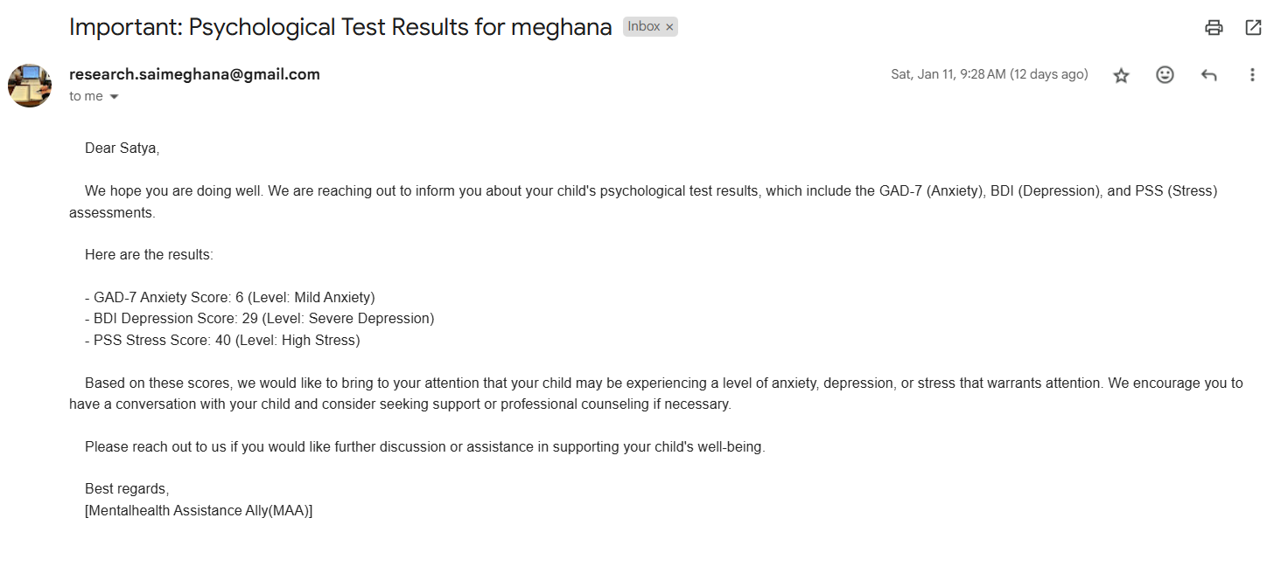

**Figure 8: Psychological Test**

Given the criticality of such results, most importantly, elevated levels of depression and stress, an automated email alert has already been successfully triggered to the respective guardian. It is pointedly reminding them about the user’s men tal health and urging immediate help and intervention before the situation could get worse and out of their control. This proactive measure, in turn, prevents the users from handling everything alone, bringing in their loving family members in time to assist them.

***Journaling*** While journaling, the user described their day as, ”I went out with my mom. I’m so happy.” Text sentiment analysis shows that the emotion detected was ”happy.” But the facial emotion tracking data shows different Fig 9: Fear: 9.59%, Sadness: 56.16% Neutral: 32.88% Happiness: 1.37% This striking contrast reveals an important truth about human expression—people often mask their true feelings. Despite writing a cheerful narrative, the user’s facial expressions indicated a dominant state of sadness, suggesting that beneath the surface, their emotional experience was far from joyful. Such discrepancies show how complex emotions are and the necessity for systems to move beyond words in order to better understand mental states. A combination of text and facial emotion analysis will lead to a better understanding, which offers better opportunities for meaningful support

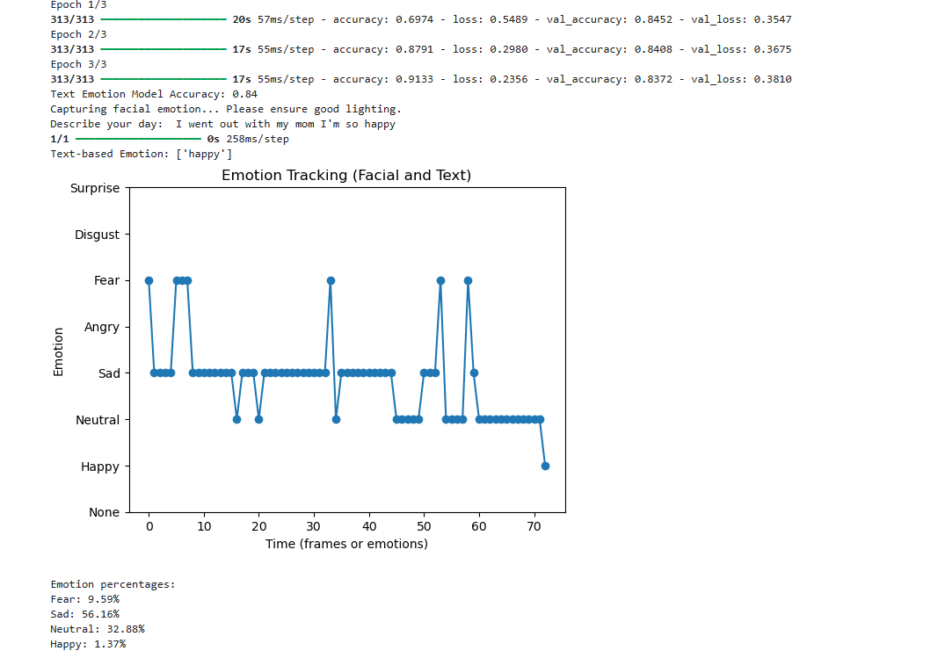

**Figure 9: Journalling**

***Chatbot*** The chatbot is a friend Fig 4, ensuring that users never feel lonely or judged. As a digital mental health counselor, it offers immediate, supportive guidance—like mental health first aid—when traditional avenues can be costly and time-consuming. Unlike conventional methods, such as consulting a doctor, which often involve appointment scheduling and limited avail ability, the chatbot offers 24/7 assistance. It’s always there when needed, bridging the gap between moments of crisis and human intervention Figure 10.

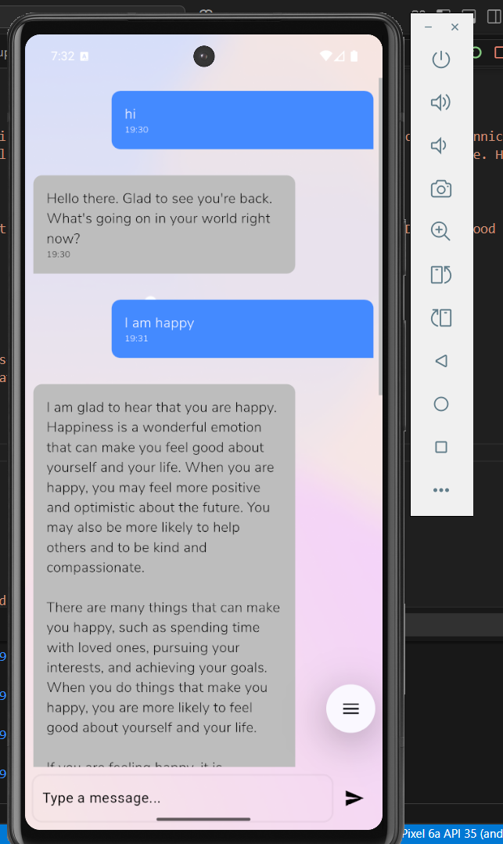

**Figure 10: Friendly Conversation**

If a user’s condition becomes overwhelming, the system sends a discreet alert to their guardian Figure 11, gently suggesting they spend quality time with the user to provide emotional support. While AI cannot replace the warmth and empathy of human care, it stands as a crucial lifeline in moments of absence, offering comfort, guidance, and connection until professional or personal help is available

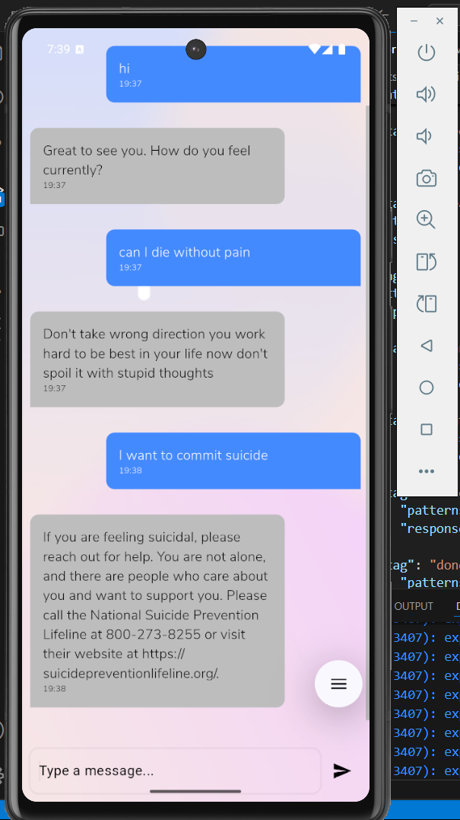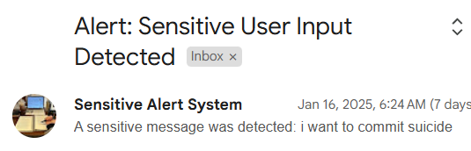

**Figure 11: When user at peek state**

***Anxiety Attack and other features*** : In the application, the ”Calm” Fig 6 button is a soothing lifeline when the user needs it most, in times of distress. In the midst of anxiety, the breath becomes shallow and erratic and can easily become uncontrol label. The feature marks the point when the attack triggers and helps lead the user to calming breathing exercises—because reclaiming control over breath is regaining calm. Emotion is the silent compass that guides our breath. When you are angry, your breath becomes heavy. The moment frustration takes over, breath gets jagged. The first thing that changes when emotions change is your breathing rhythm. That is why proper breathing is not just important; it’s transformative.

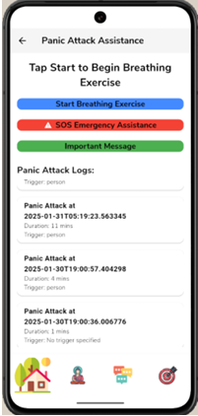

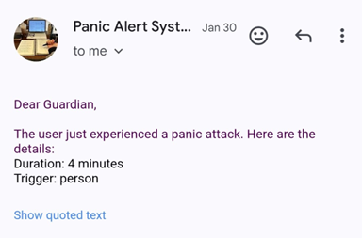

**Figure 12: Panic attack assistance emergency mail**

In case relief is not forthcoming from the guided exercises, an ”SOS Emergency” Figure 12 button is there as well. Just one tap with it and alert the user’s guardian to help him in any possible way and support his time and care of his loved ones. Such thoughtfulness with technology and mindfulness ensure that no person faces their storm alone.

**11. FUTURE SCOPE & CONCLUSION**

***Desktop- RoboPet Companion*** RoboPet Companion is an innovative response to this mental health crisis. Unlike traditional approaches, which are often limited by availability and accessibility, RoboPet provides constant, non-stigmatizing, and user-tailored support. This paper discusses the need for such a solution based on survey outcomes and outlines the application technological structure of RoboPet to automate.

***Mechanical Characteristics of RoboPet :*** RoboPet is designed with several key features to address the mental health challenges identified in the survey:- Emotion Detection: How it works RoboPet utilizes artificial intelli gence algorithms incorporated in a conveniently designed device which listens and observes user’s verbal expressions, mannerisms, and physical gestures to identify the presence of emotions distress.- Real-Time Intervention: As opposed to having to attend timed therapy sessions with the actual therapist, RoboPet caters to the user’s needs when they need it.- Privacy and Data Security: In order to reduce the amount of privacy issues all information concerning users will be encrypted and available only to the users who are authorized to have such data.- Personalization: Similarly, RoboPet listens to the user’s reactions and provides recommendations like mood management, meditating, or reading depending on the user’s preferences.

Combining all the gathered data on different age groups, the client’s report highlights that mental health problems such as decision-related doubts, depression, stress, internal pain, judgmental fear, and low confidence are massively widespread. The prevalence of these issues tends to fluctuate with age, but certain trends are noteworthy:

***Young Adults (18–34)*** are the most likely to suffer from low confidence, judgmental fear, and decision-related doubts. This age group also has a higher possibility of receiving treatment, although many have limited knowl edge of mental health services.

• Another category that still struggles is ***Middle-aged Adults (35–54)***, where the rates of depression, decision related doubts, and self-harm begin to decline slightly. Nevertheless, issues related to judgmental fear and internal pain continue to be relevant.

• ***Older Adults (55+)*** exhibit the lowest rates of decision related doubts and stress, but the highest levels of judgmental fear (100%) and internal pain. Their help-seeking behavior is lower than that of younger groups, and the majority are unaware of existing mental health facilities.

Across all age groups, a common issue is the high pro portion of individuals lacking knowledge about mental health services, which underscores the need to increase awareness. The information presented here implies that any intervention should be targeted toward specific age groups, as they face different challenges in life. However, increasing knowledge and access to mental health services must be encouraged among all individuals.

The incorporation of MAA into mental health care revolutionizes technology with personal emotional support. It is anchored in a physical Robopet: a desktop companion that is entertaining and therapeutic in nature. All the functionalities inside the application, such as mood tracking, meditation suggestions, attack detection, and streak management, are automated within this Robopet.

The Robopet observes user interactions and provides tailored prompts, such as calming exercises during moments of stress or congratulatory messages for maintaining streaks. It subtly suggests mindfulness activities like guided meditation when it senses the user might benefit from a break. In this way, it dynamically adapts to the user’s mental state, thus becoming a comforting presence, simulating companionship and enhancing emotional stability. The Robopet is more than just a device; it encourages a nurturing environment that bridges the gap between virtual care and physical presence, which enables users to attain a balanced mental state without judgment or complexity.

**12.REFERENCE:**

[1] World Health Organization. (2022, June 17). WHO highlights urgent need to transform mental health and mental health care. Retrieved from https://www.who.int/news/item/17-06-2022-who-highlights-urgent need-to-transform-mental-health-and-mental-health-care

[2] Moyle, W., Jones, C., Sung, B., Bramble, M., O’Dwyer, S., Blumenstein, M., Estivill-Castro, V. (2016). What effect does an animal robot called CuDDler have on the engagement and emotional response of older people with dementia? A pilot feasibility study. International Journal of Social Robotics, 8, 145-156

[3] Ahmed, E., Buruk, O. O., Hamari, J. (2024). Human–Robot Compan ionship: Current Trends and Future Agenda. International Journal of Social Robotics, 16(8), 1809-1860.

[4] Joglekar, P., Kulkarni, V. (2018, November). Humanoid robot as a companion for the senior citizens. In 2018 IEEE Punecon (pp. 1-4). IEEE.

[5] Jeong, S., Alghowinem, S., Aymerich-Franch, L., Arias, K., Lapedriza, A., Picard, R., ... Breazeal, C. (2020, August). A robotic positive psychology coach to improve college students’ wellbeing. In 2020 29th IEEE International Conference on Robot and Human Interactive Communication (RO-MAN) (pp. 187-194). IEEE.

[6] Jeong, S., Aymerich-Franch, L., Alghowinem, S., Picard, R. W., Breazeal, C. L., Park, H. W. (2023, March). A robotic companion for psychological well-being: A long-term investigation of companionship and therapeutic alliance. In Proceedings of the 2023 ACM/IEEE inter national conference on human-robot interaction (pp. 485-494).

[7] McGinn, C., Bourke, E., Murtagh, A., Donovan, C., Cullinan, M. F. (2019, March). Meeting stevie: perceptions of a socially assistive robot by residents and staff in a long-term care facility. In 2019 14th ACM/IEEE International Conference on Human-Robot Interaction (HRI) (pp. 602-603). IEEE.

[8] Gross, H. M., Scheidig, A., M¨uller, S., Sch¨ utz, B., Fricke, C., Meyer, S. (2019, May). Living with a mobile companion robot in your own apartment-final implementation and results of a 20-weeks field study with 20 seniors. In 2019 international conference on robotics and automation (ICRA) (pp. 2253-2259). IEEE.

[9] Iham¨ aki, P., Heljakka, K. (2021). Robot dog intervention with the Golden pup: Activating social and empathy experiences of elderly people as part of intergenerational interaction

[10] Mahoor, M. H., Lane, J. T., Pourhaghighi, H. A., & Emamian, E. S. (2022). *U.S. Patent No. 11,279,041*. Washington, DC: U.S. Patent and Trademark Office.

[11] Boyle, J. T. (2022). *U.S. Patent No. 11,439,346*. Washington, DC: U.S. Patent and Trademark Office.

[12] Youngjae, O. H., Dongwook, K. W. O. N., Kim, J., Lee, S., Seongje, C. H. O., & Han, J. (2024). *U.S. Patent No. 12,145,256*. Washington, DC: U.S. Patent and Trademark Office.

[13] Energize Lab. (n.d.). *Eilik: A little companion bot with endless fun*. Retrieved March 20, 2025, from <https://energizelab.com/consumerview/eilik>

[14] GROOVE X, Inc. (n.d.). *LOVOT 3: More than a robot, a companion*. Retrieved March 20, 2025, from <https://lovot.life/lovot-3>

[15] Miko. (n.d.). *Miko 3: The playful learning robot*. Retrieved March 20, 2025, from <https://miko.ai/products/miko-3>

[16] Misa. (n.d.). *Misa: The next-generation social robot*. Retrieved March 20, 2025, from <https://www.heymisa.com/>

[17] The Art of Living. (n.d.). *Research on Sudarshan Kriya*. Retrieved March 20, 2025, from <https://www.artofliving.org/in-en/research-on-sudarshan-kriya>

[18] Mayo Clinic. (2023). *Generalized anxiety disorder: Symptoms and causes*. Retrieved March 20, 2025, from <https://www.mayoclinic.org/diseases-conditions/generalized-anxiety-disorder/symptoms-causes/syc-20360803>

[19] Cohen, S., Kamarck, T., & Mermelstein, R. (n.d.). *Perceived Stress Scale*. Retrieved March 20, 2025, from <https://www.das.nh.gov/wellness/docs/percieved%20stress%20scale.pdf>

[20] The Art of Living. (n.d.). *The Art of Living official website*. Retrieved March 20, 2025, from <https://www.artofliving.org/in-en>